Geometry: Unit 1, Lesson 4

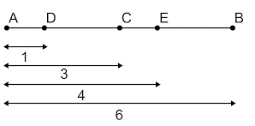
- A line segment is shown. What is the midpoint of line segment $\overline{AB}$?

C

- A line segment is shown. Point C is how much of the distance from $M$ to $D$?
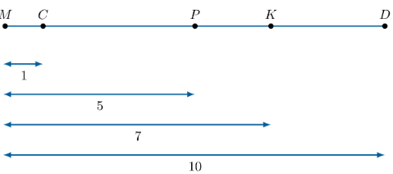

$$\frac{1}{10}$$

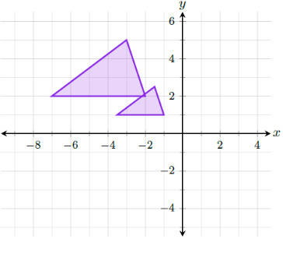
- What type of transformation is given in the example?

Dilation

